**The Gamble Kingdom Smart Contract Final Report**

**Scope of Audit**[2](https://docs.google.com/document/d/17FRIwvZTPZycO1UTZydNLysr1rA2cGgyDbrhhVcsT04/edit?pli=1#heading=h.zf94eajpvmc3)

**Check Vulnerabilities**2

**Techniques and Methods**[3](https://docs.google.com/document/d/17FRIwvZTPZycO1UTZydNLysr1rA2cGgyDbrhhVcsT04/edit?pli=1#heading=h.2et92p0)

Issue Categories [4](https://docs.google.com/document/d/17FRIwvZTPZycO1UTZydNLysr1rA2cGgyDbrhhVcsT04/edit?pli=1#heading=h.2p6a8gpqk15r)

Number of security issues per severity. 5

**Introduction**6

**Issues Found – Code Review / Manual Testing** **7**

High Severity Issues 7

Medium Severity Issues 7

Low Severity Issues 8

Informational Issues 9

**Functional Tests** **9**

**Automated Tests** **11**

**Results** **14**

**Closing Summary** **14**

## 

## 

## **Scope of Audit**

The scope of this audit was to analyze and document the Gamble Kingdom smart contracts codebase for quality, security, and correctness.

## 

## **Check Vulnerabilities**

* Re-entrancy
* Timestamp Dependence
* Gas Limit and Loops
* DoS with Block Gas Limit
* Transaction-Ordering Dependence
* Use of tx.origin
* Exception disorder
* Gasless send
* Balance equality
* Byte array
* Transfer forwards all gas
* ERC20 API violation
* Malicious libraries
* Compiler version not fixed
* Redundant fallback function
* Send instead of transfer
* Style guide violation
* Unchecked external call
* Unchecked math
* Unsafe type inference
* Implicit visibility level

# **Techniques and Methods**

Throughout the audit of smart contracts, care was taken to ensure:

* The overall quality of code.
* Use of best practices.
* Code documentation and comments match logic and expected behavior.
* Token distribution and calculations are as per the intended behavior mentioned in the whitepaper.
* Efficient use of gas.
* Code is safe from re-entrancy and other vulnerabilities.

The following techniques, methods, and tools were used to review all the smart contracts.

**Structural Analysis**

In this step, we have analyzed the design patterns and structure of smart contracts. A thorough check was done to ensure the smart contract is structured in a way that will not result in future problems.

**Static Analysis**

A static Analysis of Smart Contracts was done to identify contract vulnerabilities. In this step, a series of automated tools are used to test the security of smart contracts.

**Code Review / Manual Analysis**

Manual Analysis or review of code was done to identify new vulnerabilities or verify the vulnerabilities found during the static analysis. Contracts were completely manually analyzed, their logic was checked and compared with the one described in the whitepaper. Besides, the results of the automated analysis were manually verified.

**Gas Consumption**

In this step, we have checked the behavior of smart contracts in production. Checks were done to know how much gas gets consumed and the possibilities of optimization of code to reduce gas consumption.

**Tools and Platforms used for Audit**

Remix IDE, Truffle, Truffle Team, Solhint, Mythril, Slither, Solidity statistical analysis, Theo.

## 

## **Issue Categories**

Every issue in this report has been assigned to a severity level. There are four levels of severity, and each of them has been explained below.

**High Severity Issues**

A high severity issue or vulnerability means that your smart contract can be exploited. Issues on this level are critical to the smart contract’s performance or functionality, and we recommend these issues be fixed before moving to a live environment.

**Medium Severity Issues**

The issues marked as medium severity usually arise because of errors and deficiencies in the smart contract code. Issues on this level could potentially bring problems, and they should still be fixed.

**Low Severity Issues**

Low-level severity issues can cause minor impact and or are just warnings that can remain unfixed for now. It would be better to fix these issues at some point in the future.

**Informational** **Issues**

These are four severity issues that indicate an improvement request, a general question, a cosmetic or documentation error, or a request for information. There is low-to-no impact.

## 

## **Number of security issues per severity.**

# 

| **TYPE** | **HIGH** | **MEDIUM** | **LOW** | **INFORMATIONAL** |
| --- | --- | --- | --- | --- |
| **Open** | **0** | **0** | **0** | **0** |
| **Acknowledged** | **0** | **0** | **0** | **0** |
| **Closed** | **3** | **0** | **2** | **3** |

# **Introduction**

During the period of **May 13th, 2022 to 28th May, 2022**.

QuillAudits Team performed a security audit for **The Gamble Kingdom** smart contracts.

**Code Base**:

* <https://github.com/shrishtieth/TGK/blob/main/contracts/token.sol>
* <https://github.com/shrishtieth/TGK/blob/main/contracts/taxDistributionContract.sol>

Commit Hash : 2accb8e12a45b2134d21076fc1f544abbf35cc4a

Fixed In: 6a02ea1ada0c580aa57a69a9f039f0fb3aed975a

# **Issues Found – Code Review / Manual Testing**

## **High Severity Issues**

### **H.1 The blacklist account still can make transfer**

**Contract:** Token.sol

**Description**

As per require check on line 125 the blackListed account still can make the transfer to other non blackListed account or vice versa.

require(isBlacklisted[sender]!**=** true **||** isBlacklisted[recipient]!**=** true,"Address Blacklisted");

**Recommendation**

We recommend to put **AND** logic in require check instead of **OR** logic such that if any of the address from sender/recipent is blackListed then there should not be any transfer.

require(isBlacklisted[sender]!**=** true **&&** isBlacklisted[recipient]!**=** true,"Address Blacklisted");

**Status: Fixed**

### **H.2 setTeamWalletAddress doesn’t update the address correctly**

**Contract:**taxDistributionContract.sol

**Description**

SetTeamWallet is setting the address of **investorWallet** instead of **teamWallet.**

**Recommendation**

We recommend to put the correct **wallet** address to **teamWallet.**

**Status: Fixed**

### **H.3 setSlippage doesn’t update the address.**

**Contract:**taxDistributionContract.sol

**Description**

SetSlippage function is setting the address of **slippage** instead of **_slippage.**

**Recommendation**

We recommend to put the correct **_slippage** address to **slippage.**

**Status: Fixed**

## **Medium Severity Issues**

**NONE**

## **Low Severity Issues**

### **L.1 Require check missing**

**Contract**: **Contract:**taxDistributionContract.sol

**Description**

InitialInvestorPercentage and investorPercentage in their respective setter should be less than 10,000.

**Recommendation**:

We should put a require check while setting the InitialInvestorPercentage and investorPercentage at the time of setting it.

**Status: Fixed**

### **L.2 Owner should be multisig** We recommend to use multisig account address (gnosis-safe) for owner such that the pool creating is not malicious in future and the decentralization is achieved in the system.

**Status**:**Fixed**

## **Informational Issues**

### **I.1 Redundant code**

**Recommendation:**

The code in if and else block of distributeTax is redundant. We recommend to remove the redundancy from the code.

**Status: Fixed**

### **I.2 Gas optimizations**

1. **Contract**: taxDistributionContract.sol

**Description:**

Whenever swapTokensForEth is called the approval to uniswapV2Router With INTMAX is made which is a wastage of gas.

**Recommendation:**

We recommend to make the approval individually in other function and that should be called at the time of setting the uniswapV2Router.

*function* setRouterAddress(address router) external onlyOwner**{**

uniswapV2Router = IUniswapV2Router02(router);

*IERC20*(TGKToken).approve(address(uniswapV2Router), *2*\*\**256* - *1*);

**emit** RouterUpdated(router);

**}**

**Status: Fixed**

1. **Contract**: taxDistributionContract.sol

**Description:**

At the time of calculating investorAmount and priceImpact the denominator 10,000 is constant so we recommend to use unchecked flag at the time of dividing as no need to use inbuilt safeMath wrappers and waste the gas.

**Status: Fixed**

### **I.3 Missing netspec comments**

**Recommendation:**

We recommend adding netspec comments for each method and variables for better readability and understanding of code.

**Status: Fixed**

# Functional Tests (RINKEBY)

**Contracts**

* Token - [0xefcDc0fc735a3cBb3a1b9F7D75da65507Af06498](https://rinkeby.etherscan.io/address/0xefcdc0fc735a3cbb3a1b9f7d75da65507af06498#code)
* TaxDistribution - [0x9f385B638efEAd7BfEB3a32472CA94bAdadE93c8](https://rinkeby.etherscan.io/address/0x9f385b638efead7bfeb3a32472ca94badade93c8#code)

**Transactions**

* Burn <https://rinkeby.etherscan.io/tx/0x488a5ab64925fad4d22d1e48e2791938813ea352d77b40178c38c608a27df9ad>
* Airdrop to 2 addresses - <https://rinkeby.etherscan.io/tx/0x18000213c91ac72c51caa10ae80ac52fcf37719a0ecb8f5ab6e4b0537c4d9552>
* updateMaxBuy <https://rinkeby.etherscan.io/tx/0x789b3d19a000cceab7fbb9de7fae1f8d2b94bf9e118bcf24d6a54c168c13f379>
* ONLYOWNER can update the functionality <https://rinkeby.etherscan.io/tx/0x5e0ea9ae0603f5256452602b26b3bb10598d4a2478c8a5f6b425c0da172e733c>
* updateMaxSell <https://rinkeby.etherscan.io/tx/0xf7324598d7e80544da722e69d9e159f463e50a07a6153cf529195535ad40a882>
* updateBlackList <https://rinkeby.etherscan.io/tx/0xc18caf67fb2cee5f7ac764d1358464b9fe5c1bc6019b177e777ddad6a81add6a>
* UpdateEpoch <https://rinkeby.etherscan.io/tx/0x8447ca5b2b58fa663da172b23238cb2b27de654b967f562c326c50936e3020d3>
* Approve router contract <https://rinkeby.etherscan.io/tx/0x22053d3a19d3216f4a8dd110236379ff3466ba0952f0f34cadf4d1cdeb3c54dd>
* Amount exceed max sell value <https://rinkeby.etherscan.io/tx/0x1a1b76eacab26bda8be1279a5a67aa1d89fa4fddd4a660bd7a2bff86df480227>
* Transfer funds to tax contract <https://rinkeby.etherscan.io/tx/0xba2f72b89ecb2b286356390a95d3f9e3b1d9c0269176800a27a19913fd7b5772>
* setInvestorThresholdAmount <https://rinkeby.etherscan.io/tx/0x5b163db2048fa860f52da0beb1158faaa058548c1f1ca50594793b10ee40cbbf>
* setTeamWalletAddress (Not updated Failed) <https://rinkeby.etherscan.io/tx/0x528c48cd93add3c8ab90977e0953406ac745f122212de9097a3e8a61526ccfee>

# Automated Tests Slither:

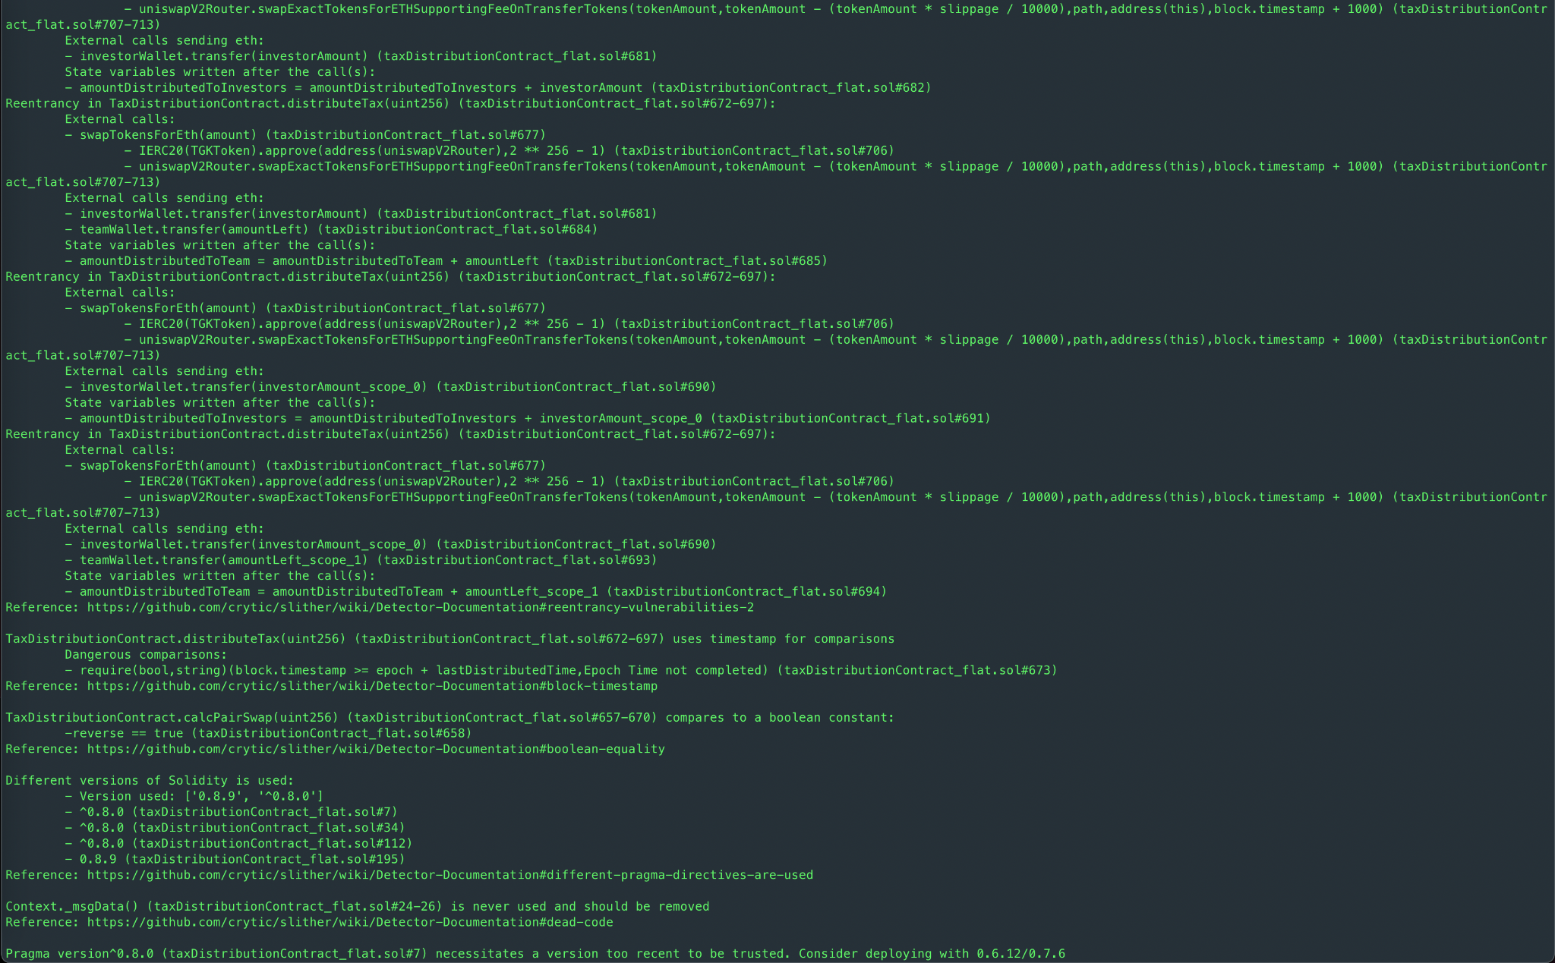

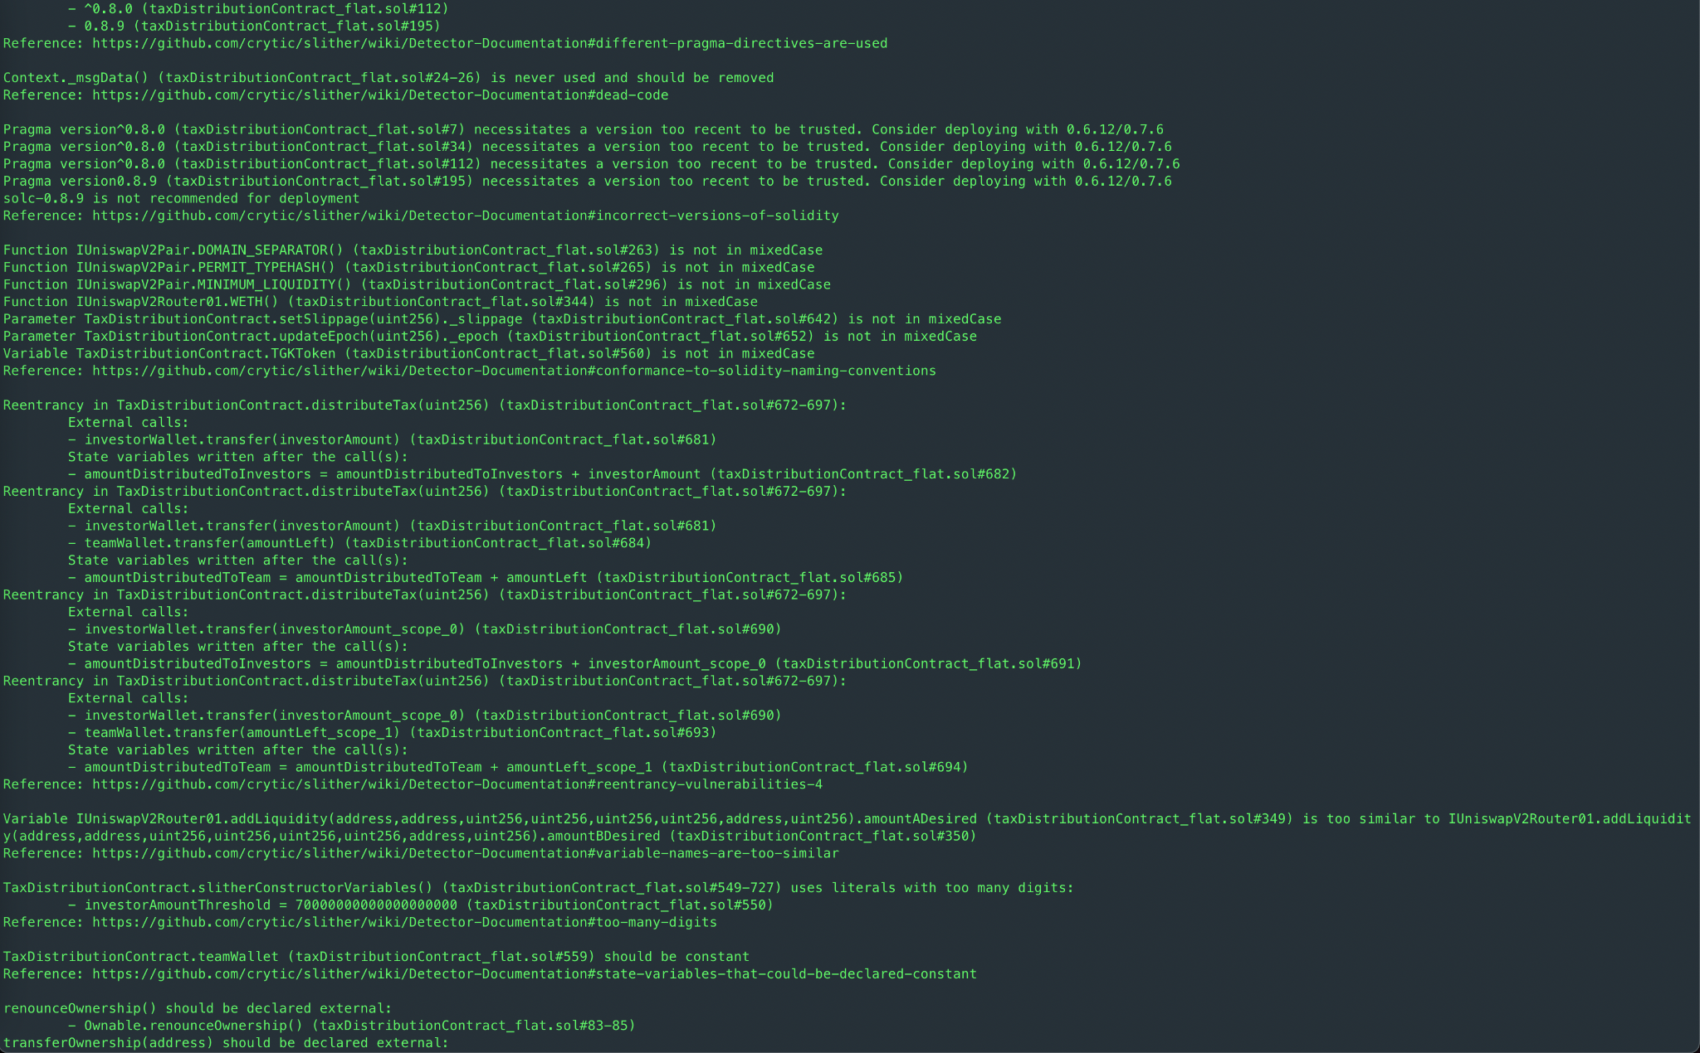

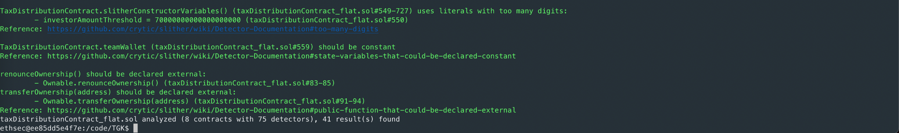

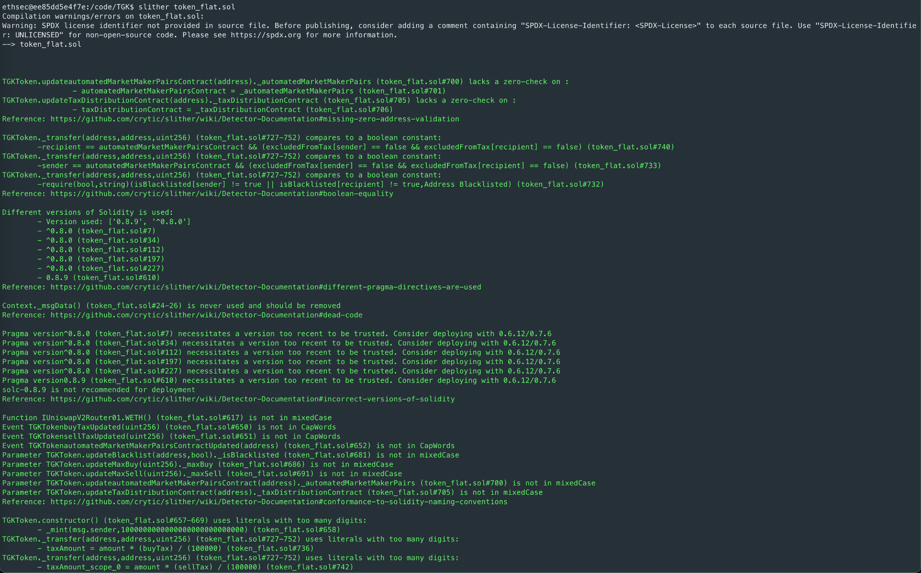

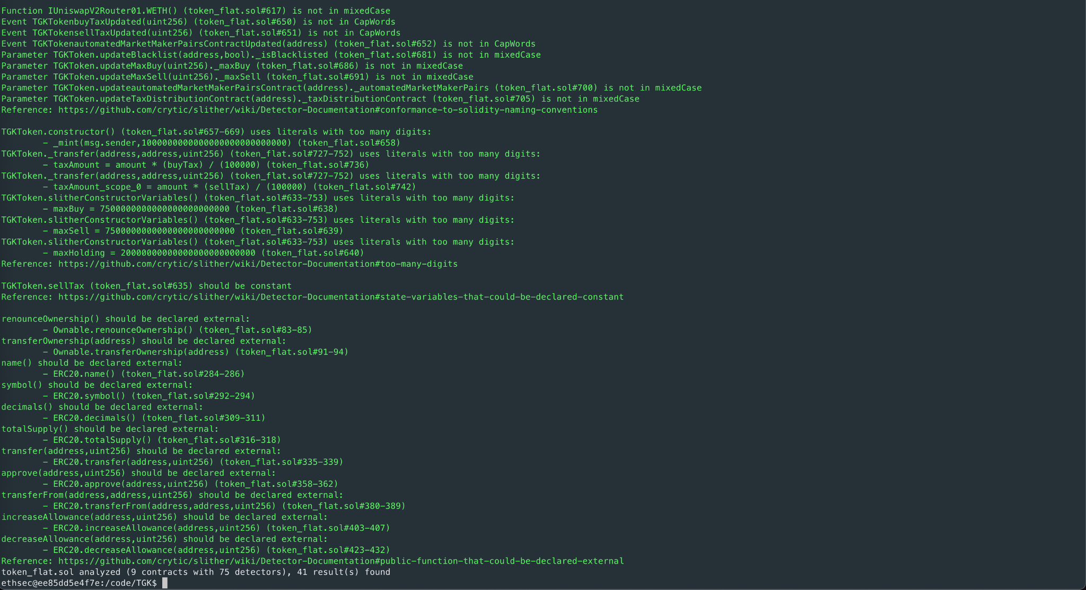

Results

A few major issues were found. Some false positive errors were reported by the tool. All the other issues have been categorized above according to their level of severity.

# 

# **Closing Summary**

Overall, smart contracts are well written and adhere to guidelines.

Numerous issues were discovered in the initial audit. In the End, The Gamble Kingdom Team resolved all Issues.

# Disclaimer

Quillhash audit is not a security warranty, investment advice, or an endorsement of the **The Gamble Kingdom platform**. This audit does not provide a security or correctness guarantee of the audited smart contracts. The statements made in this document should not be interpreted as investment or legal advice, nor should its authors be held accountable for decisions made based on them. Securing smart contracts is a multistep process. One audit cannot be considered enough. We recommend that the **The Gamble Kingdom** Team put in place a bug bounty program to encourage further analysis of the smart contract by other third parties.